SAL INSTITUTE OF TECHNOLOGY AND ENGINEERING RESEARCH
Opp. Science city, Sola-Bhadaj Road, Ahmedabad, Gujarat 380060
Ph: 079 67129000 | Website: www.sal.edu.in

Student's Weekly Report of Internship
Student Name: | Jainil Gupta
Enrollment Number: | 220670132018
Week Duration: | March 05, 2026 - March 11, 2026 (Week 10)
Name Of Organization: | Microsoft Elevate Program (via Edunet Foundation & FICE Education)
External Guide Name: | Adarsh Gupta
External Guide Contact: | 0124-4080107
Internal Faculty Guide: | Chintan Rana

Work done in last Week with description:

1. Week 10 Module: Azure DevOps and CI/CD Pipelines

Description:
Attended comprehensive session on "Azure DevOps" on March 30, 2026. Learned about DevOps culture, Azure DevOps services, and implementing CI/CD pipelines for automated build, test, and deployment workflows.

Key Topics Covered:
- DevOps culture and principles: collaboration, automation, continuous improvement
- Azure DevOps services overview: Boards, Repos, Pipelines, Test Plans, Artifacts
- Azure Boards: Agile project management, work items, sprints, backlogs
- Azure Repos: Git version control, branching strategies, pull requests
- Azure Pipelines: CI/CD automation, YAML pipelines
- Continuous Integration (CI): automated build and test on code commit
- Continuous Deployment (CD): automated deployment to staging/production
- Pipeline stages: build, test, deploy
- Build agents: Microsoft-hosted vs self-hosted
- Pipeline triggers: commit, pull request, scheduled
- Environment approvals and gates for production deployment
- Integration with GitHub, Azure Repos, Bitbucket
- Deployment to Azure App Service, Functions, AKS
- Infrastructure as Code (IaC) with ARM templates, Terraform
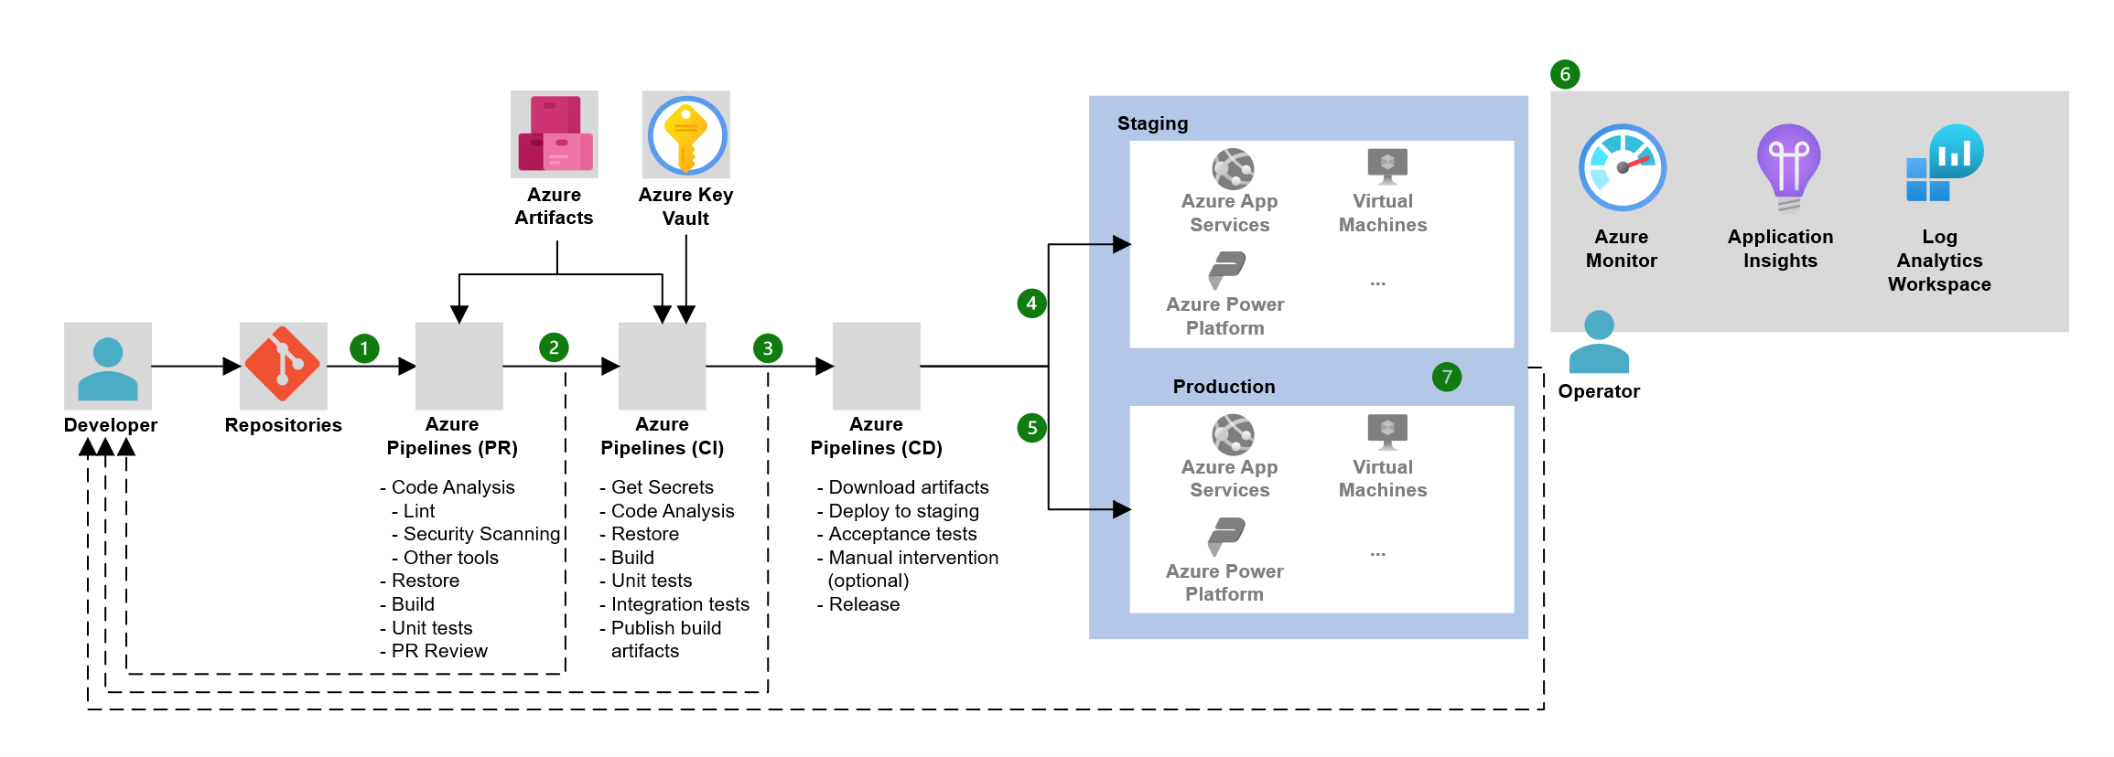
Figure 1: CI/CD pipeline workflow in Azure DevOps where code commits trigger automated build, test, and deployment stages.

Hands-on Lab Exercises:
Created Azure DevOps organization and project. Setup Git repository in Azure Repos. Created work items and sprint backlog in Azure Boards. Built simple Python web application (Flask). Created YAML pipeline for automated build and test. Configured pipeline trigger on main branch commits. Tested CI pipeline by committing code changes. Deployed application to Azure App Service via CD pipeline. Configured release approval gates. Monitored pipeline execution and logs.

Assignment Completed:
Built complete CI/CD pipeline for web application. Pipeline includes: (1) Code checkout from repo, (2) Install dependencies, (3) Run unit tests, (4) Build Docker container, (5) Push to Azure Container Registry, (6) Deploy to Azure App Service. Added environment variables and secrets management. Configured build status badges. Submitted pipeline YAML and documentation.
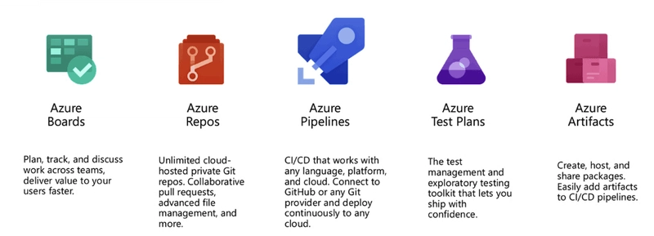
Figure 2: Azure DevOps service ecosystem including Boards, Repos, Pipelines, Test Plans, and Artifacts.

2. Week 10 Module: Azure Monitor and Application Insights

Description:
Attended session on "Azure Monitor and Application Insights" on April 1, 2026. Learned comprehensive monitoring, logging, and observability solutions for Azure applications and infrastructure.

Key Topics Covered:
- Azure Monitor overview: unified platform for monitoring Azure resources
- Metrics vs Logs: time-series data vs diagnostic data
- Azure Metrics: resource performance metrics (CPU, memory, network)
- Azure Logs: Log Analytics workspace, Kusto Query Language (KQL)
- Application Insights: APM (Application Performance Monitoring)
- Telemetry data: requests, dependencies, exceptions, custom events
- Application Map: visualize dependencies and performance bottlenecks
- Live Metrics: real-time performance monitoring
- Availability tests: endpoint monitoring and uptime checks
- Alert rules: metric alerts, log alerts, action groups
- Dashboards: custom monitoring dashboards with charts and metrics
- Diagnostic settings: routing logs to storage, event hubs, Log Analytics
- Smart detection: AI-powered anomaly detection

Hands-on Practice:
Enabled Application Insights for Azure Function App. Instrumented Python code with Application Insights SDK. Monitored function execution requests and response times. Created custom telemetry events for tracking specific actions. Wrote KQL queries in Log Analytics to analyze application logs. Created metric alert for high failure rate (>5% in 5 minutes). Configured email action group for alert notifications. Built monitoring dashboard with key performance indicators. Tested availability monitoring with URL ping test. Analyzed application performance using Application Map.

Assignment:
Implemented comprehensive monitoring solution for web application. Created 5 KQL queries for different scenarios: error analysis, performance trends, user behavior, dependency tracking, custom events. Configured 3 alert rules: high error rate, slow response time, availability failure. Built monitoring dashboard with 8 tiles showing key metrics. Submitted monitoring documentation with sample queries and alert configurations.

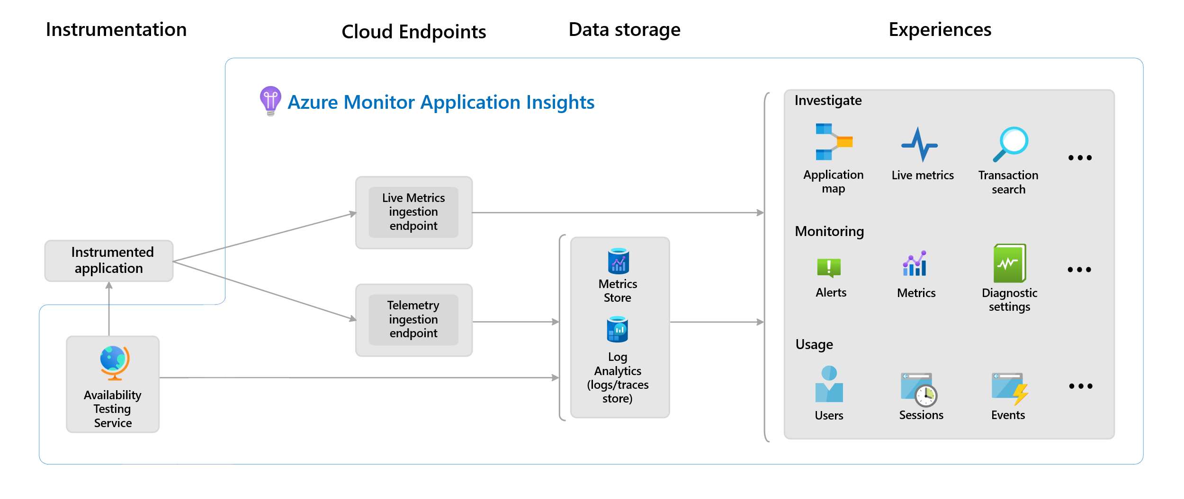
Figure 3: Azure monitoring architecture collecting metrics, logs, and telemetry through Azure Monitor and Application Insights.

3. Week 10 Module: Azure Security and Best Practices

Description:
Attended session on "Azure Security" on April 3, 2026. Learned security best practices, Azure security services, identity management, and compliance frameworks for securing cloud applications.

Key Topics Covered:
- Azure security fundamentals: defense in depth, shared responsibility model
- Azure Active Directory (Azure AD): identity and access management
- Multi-Factor Authentication (MFA) and Conditional Access
- Role-Based Access Control (RBAC): least privilege principle
- Azure Key Vault: secrets, keys, and certificates management
- Managed Identities: authentication without storing credentials
- Azure Security Center: unified security management and threat protection
- Network security: NSGs, Azure Firewall, DDoS Protection
- Data encryption: at rest (Storage Service Encryption) and in transit (TLS/SSL)
- Azure Policy: governance and compliance enforcement
- Azure Blueprints: repeatable deployment of compliant environments
- Compliance frameworks: ISO, SOC, GDPR, HIPAA
- Security best practices: principle of least privilege, regular audits, monitoring

Hands-on Practice:
Created Azure Key Vault to store secrets and connection strings. Configured access policies for applications and users. Implemented Managed Identity for Azure Function to access Key Vault. Removed hard-coded secrets from application code. Configured RBAC roles for resource group (Reader, Contributor, Owner). Created custom RBAC role with specific permissions. Enabled Azure Security Center recommendations. Configured Network Security Group rules for inbound/outbound traffic. Tested secret rotation in Key Vault. Reviewed compliance score in Azure Policy.

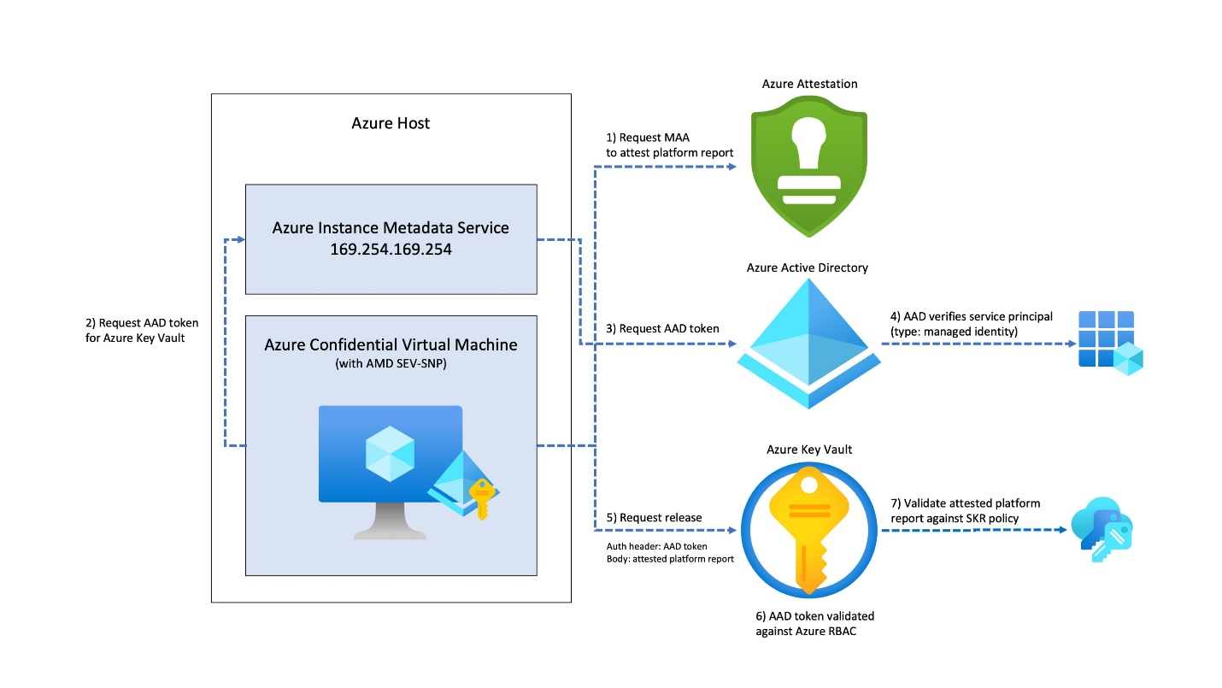
Figure 4: Azure security architecture showing identity management, RBAC access control, and secure secret storage using Azure Key Vault.

Assignment:
Security audit and remediation project: (1) Identified security issues in sample application (hard-coded secrets, public storage, no MFA), (2) Migrated secrets to Azure Key Vault, (3) Configured Managed Identity for authentication, (4) Implemented RBAC for least privilege access, (5) Enabled storage firewall and private endpoints, (6) Documented security improvements and compliance checklist. Submitted security assessment report.

4. Microsoft Azure Fundamentals (AZ-900) Certification Exam

Description:
Completed Microsoft Azure Fundamentals (AZ-900) certification exam on April 2, 2026. This validates foundational knowledge of cloud concepts, Azure services, security, pricing, and support.

Exam Preparation:
- Completed all Microsoft Learn modules for AZ-900
- Took 5 full-length practice exams (average score: 85%)
- Reviewed weak areas: Azure pricing calculator, support plans, SLAs
- Studied flashcards for Azure services and terminology
- Reviewed exam skills outline and objectives

Exam Details:
- Exam Date: April 2, 2026
- Format: Online proctored exam (60 minutes)
- Questions: 40-60 multiple choice, case studies, drag-drop
- Passing Score: 700/1000
- Result: PASSED with score of 820/1000
- Certificate ID: [Received via email]

Achievement:
Successfully earned Microsoft Azure Fundamentals certification, validating cloud computing knowledge and Azure platform expertise. This industry-recognized credential demonstrates proficiency in cloud concepts, Azure services, security, privacy, compliance, and pricing. Certificate added to LinkedIn profile and resume.

5. GTU Project - Azure Deployment and Testing

Description:
Started applying learned Azure services to project implementation. Created production Azure infrastructure and deployed basic components for testing integration.

Azure Infrastructure Setup:
- Created Resource Group: 'BorderSurveillance-RG' in Central India
- Deployed Storage Account: 'bordersurv2026' with Hot tier
- Created Blob containers: 'surveillance-videos', 'processed-frames', 'alerts'
- Configured lifecycle policy: move to Cool tier after 30 days
- Deployed Function App: 'BorderDetectionFunctions' with Python 3.10
- Created Cosmos DB account: 'bordersurv-cosmos' with SQL API
- Created database 'SurveillanceDB' with container 'Alerts' (partition key: /date)
- Configured Key Vault: 'bordersurv-vault' for storing secrets
- Setup Application Insights for monitoring

Testing Completed:
Uploaded sample surveillance video to Blob Storage (50MB test file). Created test Azure Function to trigger on blob upload. Verified function execution and logging in Application Insights. Inserted test alert record into Cosmos DB. Retrieved data using SQL queries. Tested end-to-end connectivity between all services. Documented deployment architecture and connection strings (stored in Key Vault).
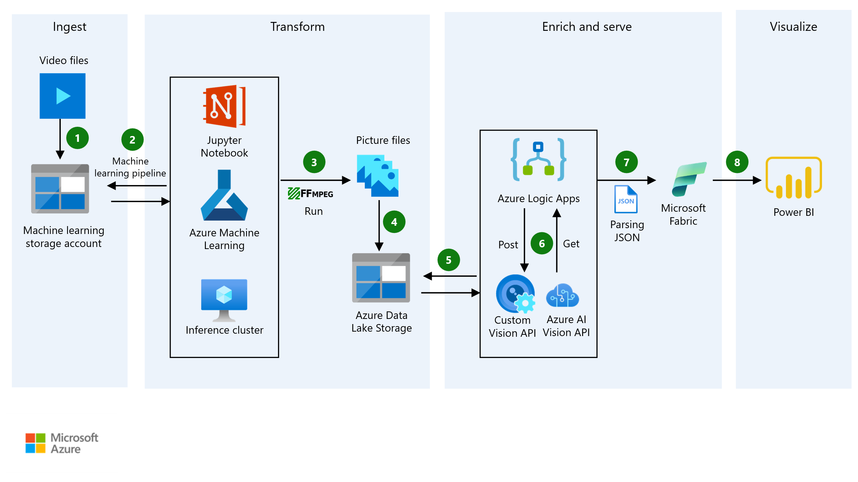
Figure 5: Azure architecture integrating Blob Storage for video data, Azure Functions for processing, and Cosmos DB for storing alerts and metadata.

Next Steps:
Azure infrastructure is ready for YOLOv8 model integration in Week 11. Will deploy actual detection code and anomaly detection models. Current setup validated cloud architecture and service connectivity.

6. Internship Completion Preparation

Description:
Started preparing for final internship presentation and documentation. Compiled learning achievements from all 10 weeks and organized deliverables.

Preparation Activities:
- Created presentation outline covering all 12 weeks
- Compiled list of completed modules and certifications
- Documented skills acquired: Python, Power BI, ML, Azure, DevOps
- Updated project README with final architecture
- Prepared demo plan for Week 12 presentation
- Organized all weekly reports and assignments

Plans for next week:

1. Complete Final Microsoft Elevate Modules
- Attend any remaining Azure advanced topics sessions
- Complete all pending module assessments
- Review and consolidate learning from all modules

2. Project Implementation and Integration
- Deploy YOLOv8 model to Azure Functions
- Implement detection pipeline with Blob triggers
- Integrate anomaly detection models
- Setup alert system with email/SMS notifications
- Test end-to-end pipeline with sample videos

3. Power BI Dashboard Development
- Connect Power BI to Azure Cosmos DB
- Create visualizations: detection metrics, anomaly heatmap, timeline
- Build interactive dashboard with slicers and filters
- Test real-time data refresh

4. Documentation and Testing
- Complete project technical documentation
- Create deployment guide and user manual
- Perform end-to-end system testing
- Record demonstration videos

5. Final Presentation Preparation
- Finalize presentation slides (PowerPoint)
- Prepare live demo script
- Practice presentation delivery
- Prepare Q&A responses for common questions

Total Working Hours: 38 hours
Signature of Student: _____________________
The above entries are correct, and the grading of work done by Trainee is:
Excellent | Very Good | Good | Fair | Below Average | Poor
☐ | ☐ | ☐ | ☐ | ☐ | ☐

Signature of External Guide with Company Seal:
Date: ___________
Signature of Internal Guide: _____________________
Date: ___________

